[E111] Cooling valve

At first, switch on the machine, select the service menu and open all the valves (valves can be removed only in open position).

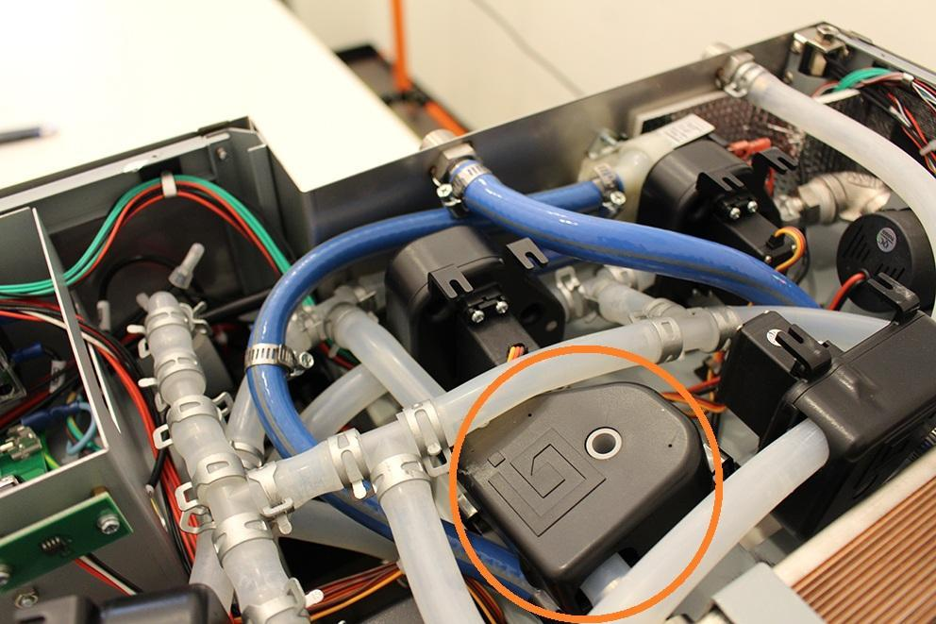

Pull off the indicated hose clamps and silicone tubes from the fittings. Bend the silicone tubes for an easier assembling.

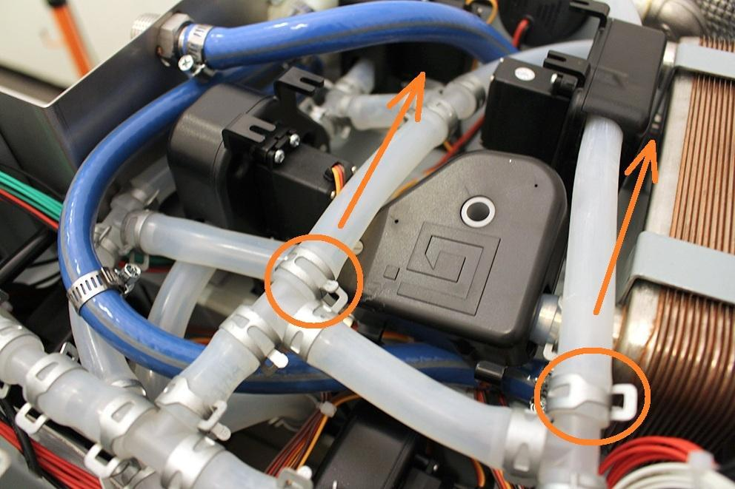

Pull of the indicated hose clamp.

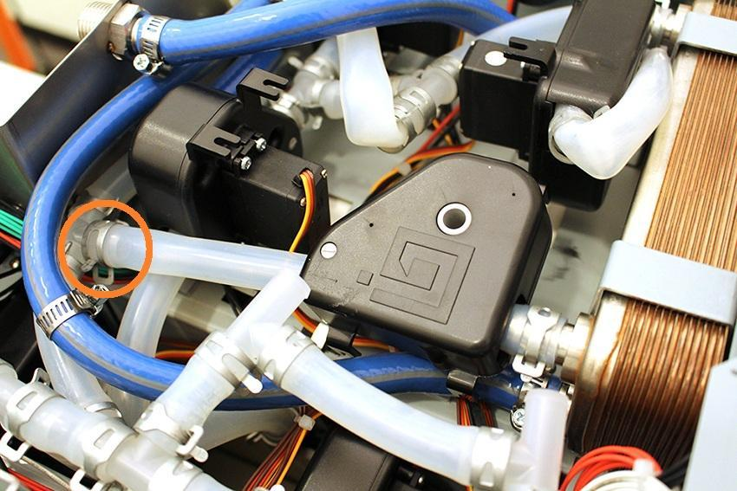

Pull off the silicone tube from the fitting and Disconnect the plug of the valve from the MCU panel. Now you can remove the valve.

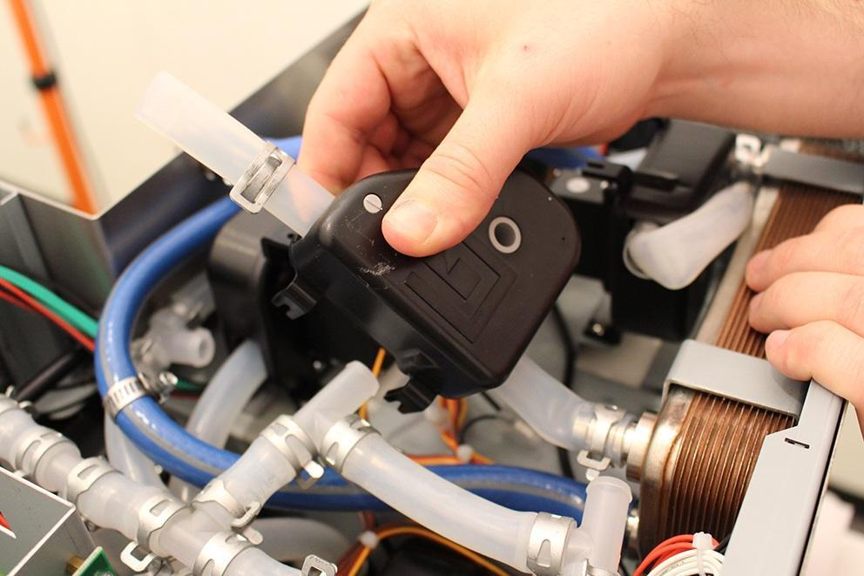

After you removed the valve, please check if the inner wall of the silicone tube is clinged together. If it is clinged together, do not change the valve, you only have to do is to separate the inner walls.

Reassemble consists of the same steps in reverse.

Make sure that the indicated hose clamp is in the proper angle. Otherwise you cannot reassemble the lower sheetmetal because of the cooling fan.

